7th Grade English Language Arts Syllabus - 2018-2019 School Year
Teacher: Ms. Thais Martin Email: thais.martin@dcssga.org Phone:770-651-5573
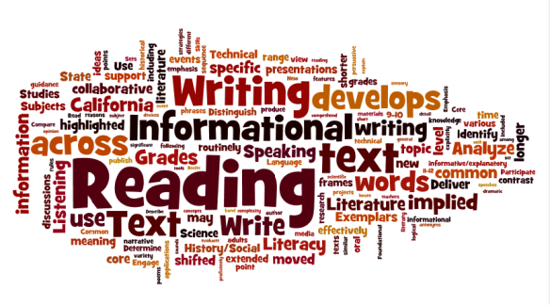
Welcome to 7th grade Language Arts! I am looking forward to working with you. This year will present several learning opportunities as we actively partake in the writing, grammar, reading, listening, and speaking areas of English.

The topics of study are:
- Literary text
- Informational text
- Narrative Writing
- Informative/Explanatory Writing
- Argumentative Writing
- Routine Writing (notes, journals, summaries, and short responses)
- Language (conventions of grammar)
- Research Connections
Grading Scale:  A 90 - 100  B 80 - 89  C 71 - 79  D 70  F Below 70 | Category Weight:  Classwork 40%  Assessments and Projects 30%  Quizzes/Formative Assessments 20%  Homework/Classroom Engagement 10%

- Class Assignments: Most work is done in class, but anything not completed will become homework and is still required and considered class work.
- Class Participation: Each student is required to participate in the activity and lesson presented. Some activities will be an individual effort, a part of a collaborative pair, or a part of a small group. If your student has an issue with group work, please let me know. Students will be graded based on how they respond to the tasks given to them as an individual and as a group member.
- Independent Reading: In middle school, students should choose reading books based on their Lexile Score (results provided on their Georgia Milestones/ myOn/or STAR 360) or a book assigned by the teacher. ALL students need to have an independent reading book with them at ALL times.
- Assignments and Make-up Work: Students are expected to complete the assignments by the assigned due dates. Exceptions may be allowed in the case of excused absences (per county policy).
- HOMEWORK: Homework will consist of completing/practicing an assignment/concept, studying notes, or reading Monday through Thursday.
Class Materials  - 2 Composition Notebooks  - 2 pocket folders  - Lined notebook paper  - Pencils and pens  - Index cards  - Highlighters  - Post-It sticky notes | Class Expectations…  Students are expected to have a cooperative, respectful attitude and must follow all classroom and school-wide rules and procedures.  Follow directions  On task to complete assignments  Come to class prepared  Use kind words and actions  Silence all electronics
Citations
When a student does not follow the rules and procedures in the classroom or on campus, he or she can be issued a citation.

- First time: Verbal warning
- Second time: Student-Teacher conference with parent contact (or Lunch Detention)
- Third time: Detention and parent contact
- Fourth time: Parent contact and Team ISS
- Fifth time: Parent-Teacher conference
- Sixth time: Office Referral with parent contact

- Tutoring: Email or call me if you feel your child needs extra help. Tutoring will be after school (4-4:45) Tuesdays or Thursdays when requested ONLY. Rides need to be here promptly.

- NOTE TO PARENTS AND GUARDIANS: Please call or email your child's instructor if you have comments or concerns. It is the student's responsibility to inform you of his or her grades. Individual student progress can also be tracked through Infinite Campus. Please use this resource to remain informed of your child's weekly grades. Interest and encouragement at home in student activity and progress is always beneficial to student performance at school.
**Please note the syllabus is subject to change. **
Please keep this syllabus as a reference. Please sign the attached page and return it to me promptly. Thank you.

Acknowledgement of receipt of Ms. Martin’s 2018-2019 syllabus:

___________________________________________________________________________________________________________
Student Date Class Period

__________________________________________________________________________________________
Parent Date

__________________________________________________________________________________________
Parent Telephone Number Parent Email address

